MODULE11
SIZE SEPARATION
Separation of comminution products on basis of size is called sizing.
Importance of sizing:
- To carry out further processing or for selling
- To gauge (estimate the amount or level) the effectiveness of crushing and grinding operation also to taken up to control size reduction process.

Concept of mesh
The mesh number system is a measure of how many openings there are per linear inch in a screen. Sizes vary by a factor of √2. This can easily be determined as screens are made from wires of standard diameters, however, opening sizes can vary slightly due to wear and distortion. As the mesh number increases the no of opening increases per liner inch , where as the size of the opening decreases.
Screening
Screen are attached with all types of crushing units at feed and discharge end
• Screening: it is carried out by passing the comminution products over a surface provided with opening of desired size.
• Screening equipment may be stationary or moving bar punched metal plate or woven wire mess.
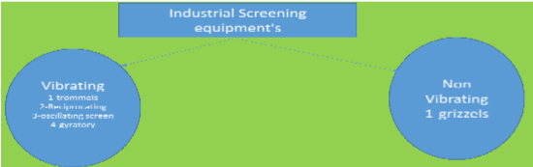
Grizzels (non vibrating) stationary screen
- Screening large size particles more than 25 mm (used for primary screening).
- consists of simple parallel heavy wear resistance manganese steel bars or rails separated by required space at the ends
- these bar may be laid
- usually cross section of the bar is trapezoidal with wide base upward to prevent clogging or weeding of
Vibrating screen:
- used for treating large tonnage of material
- vibrating moting(shaking motion) is imparted by cam,eccentric unbalanced fly wheel,or electromagnetic mass.
- it may be single doubled, or triple decked to obtain different size of particle from single feed
- these screens can be used upto 35 mesh
- amplitude is usually 6-8 mm
- angle is around 20-30 degree for dry and 5-10 degree for wet
- rpm is varied below 1200 -1800.
Oscillating screen :
- these are characterized by relatively low speed in the range of 300- 400 rpm in plane ,essentially parallel to screen
- the riddle is a screen driven in a oscillating path by an eccentric or other mechanism attached to it
Reciprocating screen :
- these are driven by an eccentric under the screen at the feed end
- the motion varies from gyratory (up to 50 mm dia ) at feed end to a reciprocating motion at the discharge end the inclination is about 5 degree
Trommels ( vibrating screen)
- there are revolving screen or drum separator type consist of a screen in the form cylindrical or conical in shape rotated about its axis
- the material is feed at one end of the screen , the undersized materials falls through the screening surface while the oversize is conveyed by rotating motion down the incline to the discharge end .
- it can handle both dry or wet feed
- it can separate several size feed by using a series of screen from coarset to finest.
- cheap and most suitable for washing of coal and iron ore

Gyratory screen :
- contains removable and replicable circular decks or trays for different size products .
- it works both gyratory and vertical motion to the screen decks
Factors affecting screening performance:
- size
- shape
- orientation
- feed rate
- Angle of discharge
- Percent opening area
- Type of vibration
- Moisture content
- Feed material
Limitation of screening:
- There is a limitation of screen process since very fine particles (size is also very similar)cannot be sorted effectively into two or more products .
- Sorting (separation can only be possible on the basis of velocity with which the grain falls through a fluid medium.

Performance of screens

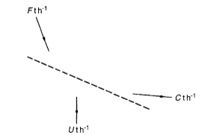
Consider a screen the feed to which is F t /h Two products are generated. A coarse product of C t/ h overflows from the screen, and a fine product of U t/ h pass through the screen.
Let f be the fraction of material above the cut point size in the feed; c be the fraction of material above the cut point size in the overflow; and u be the fraction of material above the cut point

The mass balance on the screen is:
F=C+U
The mass balance of the oversize material is"
Ff =Cc + Uu
and the mass balance of the undersize material is:
F(1 - f) = C(1 - c) + U(1 - u)
Hence C/F= f-u /c-u and U/F=c-f/c-u
The recovery of oversize material into the screen overflow is
=Cc/ Ff= c(f - u) /f(c-u)
And the corresponding recovery of undersize material in the screen underflow is
U(1- u) /F(1 -f) = (1 - u)(c - f)/ (1-f)(c-u)
These two relationships measure the effectiveness of the screen
E=c (f - u) (1 - u) (c- f)/f(c - u)2(1 - f)

CLASSIFICATION
Classification can be defined as the method of separation or concentration by difference in the settling rate due to variation of particle size shape and density in a fluid medium.
Fluid medium: here fluid medium is water but in modified condition such as rising at uniform rate, changing density, addition of suitable reagent, and passing air bubble.
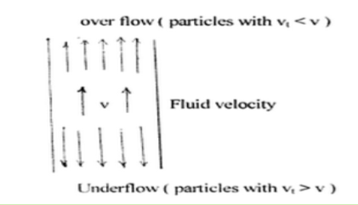
Classifier consists of a sorting column in which a fluid rises at uniform rate, particles introduced into the shorting column sink and report as underflow if their terminal velocity are greater than the velocity of water , and in other hand if their terminal velocity is less than upward velocity of the fluid , it rises and report as over flow.
Sorting column/Hydraulic classifier
- Working principle- difference in the settling rate of particles of feed pulp against the rising water current.
- Unit is simple in design
- consist of series of conical sorting columns
- The columns in series are successively larger in size with relatively lower current velocity.
- The relative rate of settling against the varying up flow current in each of the conical pocket accumulates coarser particle in the first to finest in the last
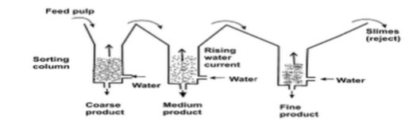
Spiral and rake classifier
- Mechanically driven devices The unit drag coarser sandy sediments from the settled feed pulp by a continuously revolving spiral along the bottom of an inclined surface to a high discharge point on one end of the settling tank the fines over flow at the other end .
- Rake classifier is a variation in the mechanism of shifting the coarser component .the rake dip into the feed pulp ,move in an eccentric motion along an inclined plane for a short distance then lift it up and go back to the starting point to repeat the operation
- Spiral classifier are prefer over rake as the material does not slides backward.

Spiral
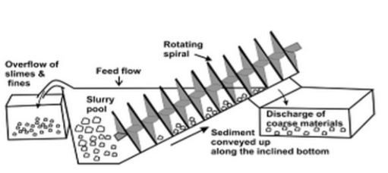
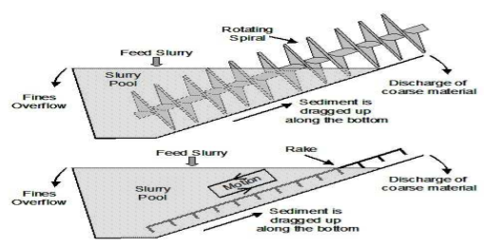

HYDROCYCLONE
This is a continuously operating classifying device that uses centrifugal force to accelerate the settling rate of particles. It is one of the most important device in the Mineral Industry. Its main use in mineral industry being as classifier, which has proved extremely efficient at fine separation size. It is widely used in closed circuit grinding operation but has found other uses, such as de-sliming and thickening. It has replaced mechanical classifier in man applications. Its advantage being its simplicity and high capacity relative to its use.
Applications:-
1. As classifier in mineral processing
2. In paper mill to remove sand, staples, plastic particles and other contaminants.
3. In the drilling industry to remove sand from expensive clay.
4. In industry to separate oil from water or vice-versa
5. In metal working to separate metal object from cooling liquid.
6. In potato processing plant to remove starch from waste water.
Design:-
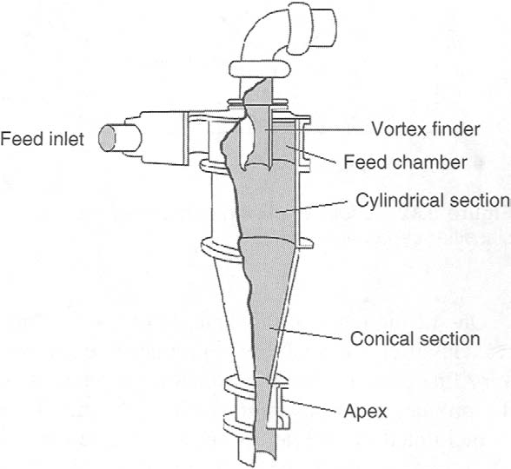
Materials of hydro cyclone:-
1. Steel Cast
2. Aluminium
3. Fiber glass
4. urethane
5. Stainless steel
Materials of liners:-
1. Natural Gum Rubber
2. Synthetic Rubber
3. Urethane
4. Nitride bonded silicon carbide
Variable associated with geometry:-
1. Cyclone diameter
2. Vortex finder diameter
3. Inlet area
4. Apex diameter
5. Cone angle
6. Cylindrical section length
Operating variables:-
1. Internal viscosity of slurry
2. Feed percent solid
3. Inlet pressure
4. Specific gravity of solid
5. Feed size distribution
Method of Separation:-
Two types of forces act on particle-
- Centrifugal force (F_{c})
- Drag force (F_{d})
F_{c} = mV²/R =4r³ (▲_{p} -▲_{m})V²/3R
Where, r= Radius of particle
▲_{p} = Particle density
▲_{m} = Media density
R= Radius of cylindrical part
There are two cases;-
- When ▲_{p} > ▲_{m} , then particle gain positive centrifugal force and
thrown at inner wall of cyclone and reports to underflow
- When ▲_{p} < ▲_{m} , then particle is not thrown outside. It moves toward
centre and caught in inner spiral and moves upward.

Advantage:-
1. More efficient (finer size range)
2. Less floor space
3. Less residence time of particle within the cyclone
4. Oxidation of particle is reduced within the circuit
5. Mill circuit can rapidly be brought into balance
6. Low maintenance
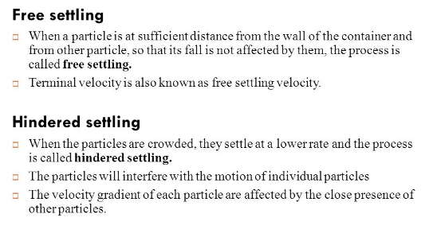
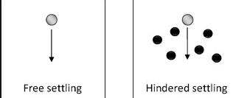

STOCKS LAW AND TERMINAL VELOCITY (SETTLING VELOCITY)
Terminal Velocity
As the body falls through a medium, its velocity goes on increasing due to ‘gravity. Therefore, the opposing viscous drag which acts upwards also goes on increasing. A stage reaches when the true weight of the body is just equal to the sum of the upward thrust due to buoyancy and the upward viscous drag. At this stage, there is no net force to accelerate the body. Hence it starts falling with a constant velocity, which is called terminal velocity.It is maximum constant velocity acquired by the body while falling freely in a viscous medium. It is attained when force of resistance of a medium is equal and opposite to the force of gravity.
When a small spherical body falls freely through a viscous medium, three forces act on it.
1- a gravitational force acting acting downwards
2-an upward buoyant force due to the displaced fluid
3-a drag force acting upwards

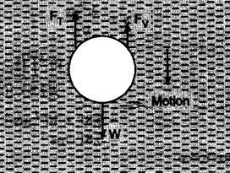

Let p be the density of the material of the spherical body of radius r and p0 be the density of the medium.
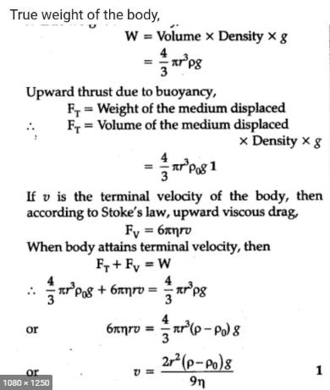
This expression is called stokes law
Here η = fluid velocity
V= terminal velocity

- V = (3gd (Ds-Df)/Df)1/2
This is newton's law of turbulent resistance.
Where d- diameter of spherical particle
Ds- density of solid
Df- density of fluid
M’-mass of the displaced liquid
M- mass of the particle
Stokes' law makes the following assumptions for the behaviour of a particle in a fluid:
1-Laminar Flow
2-Spherical particles
3-Homogeneous (uniform in composition) material
4-Smooth surfaces
5-Particles do not interfere with each other.

Stokes law vs newton's law
- Stockes law is valid for particles of size below about 50micrometer in dia.
- The upper size limit is determined by dimensionless reylond number.
- Newtons law is valid for particles of size greater than 0.5 cm in dia

